**MYSQL INSTALLATION**

1. 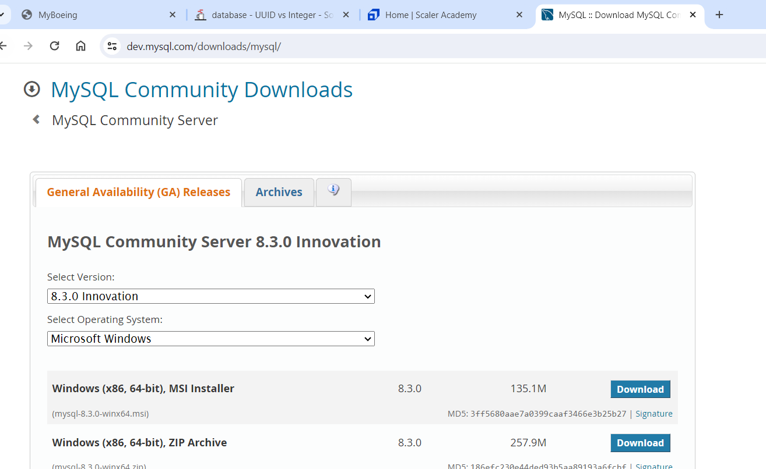
2. Download the mysql installer
3. And then download and install mysqlserver and workbench from installer

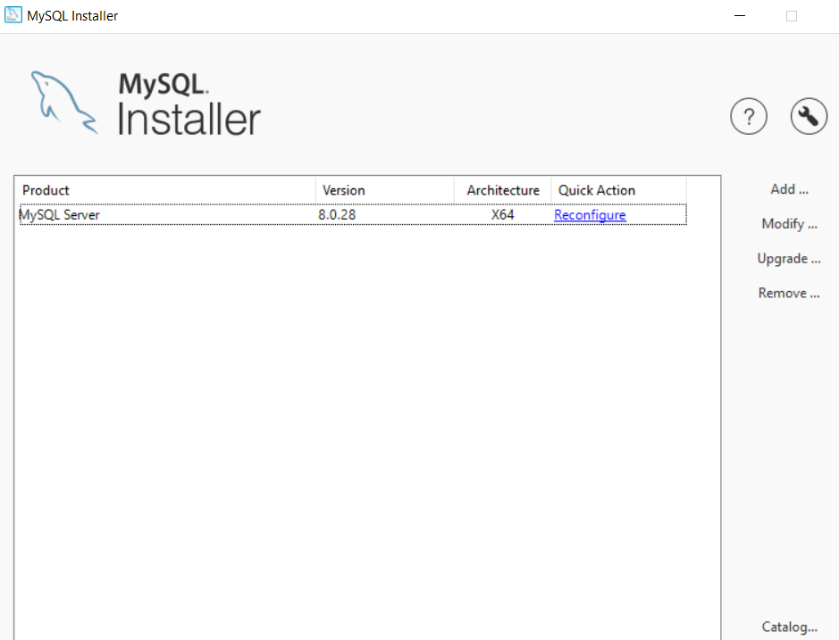

1. Once installed put the path in system properties **C:\Program Files\MySQL\MySQL Server 8.0\bin**
2. Open cmd and check

